Pre Lab

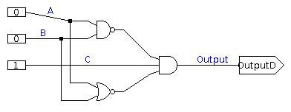

Half Adder

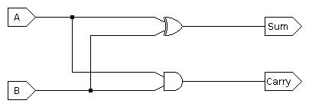

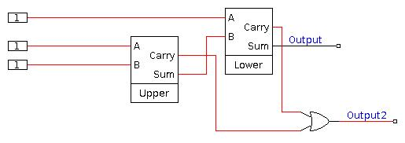
Full Adder

Testing of our half adder:

jlsCircuitTester version 1.0.6.
Current build Wed Dec 16 15:13:46 EST 2015
Run "jlsCircuitTester --license" to see full license.

All 4 tests passed
Max time required: 10

Four Bit Adder:
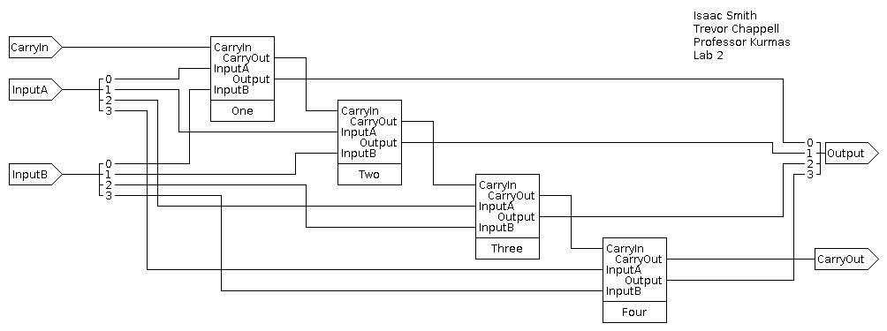

16 Bit Unsigned Adder:

